Appendix A. STCML2 Dashboard Walkthrough
This appendix gives the full section-by-section walkthrough of the STCML2 dashboard shown in Figure 21, referenced from the Model Deployment section (Section 2.4). Sections are presented in their on-screen order, A to F.
Before using the tool, the user must select a mode, monthly or hourly using the buttons in section G, then continue using the other sections in the dashboard. As shown in Figure 1,the dashboard has six main 6 sections as follows:
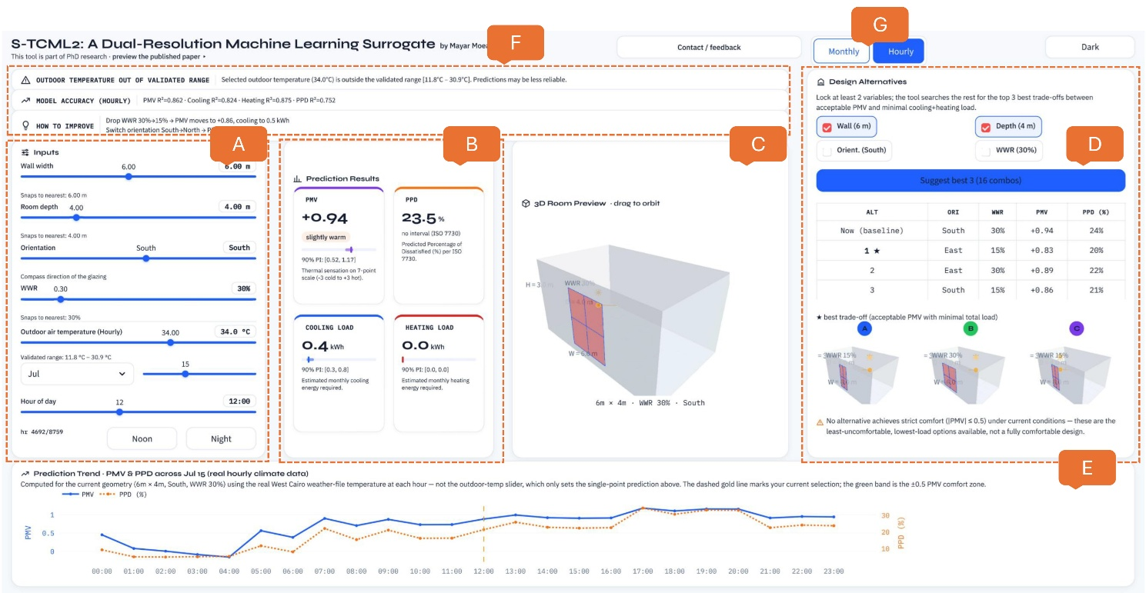
Section A: Inputs
This section lets the user define the room geometry and the outdoor climate condition. The length of the exterior wall that contains the window. Room depth (2 to 9 m): The distance from the exterior wall to the back of the room.Orientation: The compass direction that the window faces (North, East, South, or West). This direction controls how much direct solar radiation enters the room. Window-to-wall ratio (WWR) (15% to 90%): The fraction of the exterior wall that is glazed (covered by window glass), rather than solid wall. Outdoor air temperature: The temperature of the air outside the room. In hourly mode, the user also selects a month, a day, and an hour of the day. In monthly mode, the user selects a month only.
If the selected outdoor temperature is outside the range covered by the training data, the tool displays a warning banner, because predictions outside this range are less reliable.
Section B: Prediction Results
This section reports the model's predictions for the current design, shown as four cards. PMV (Predicted Mean Vote): A thermal-sensation index on a seven-point scale, from -3 (cold) to +3 (hot). A value near 0 indicates thermal neutrality, which is the target comfort condition defined by ISO 7730.PPD (Predicted Percentage of Dissatisfied): The percentage of occupants who are expected to feel thermally uncomfortable, as defined by ISO 7730. A lower percentage indicates better comfort. Cooling load: The estimated energy (in kilowatt-hours) required to cool the room under the current conditions. Heating load: The estimated energy (in kilowatt-hours) required to heat the room under the current conditions.
For PMV, cooling load, and heating load, the tool also shows a 90% prediction interval — the range in which the true value is expected to fall with 90% probability. This interval expresses the statistical confidence of the model, not a design tolerance.
Section C: 3D Room Preview
This column shows a three-dimensional geometric model of the room, drawn to scale from the current input values (wall width, room depth, orientation, and window-to-wall ratio). The window is shown in blue when the predicted PMV indicates comfort, and in red when it indicates discomfort, giving an immediate visual signal. A small sun symbol indicates the direction of solar exposure, based on the selected orientation. The user can rotate the model freely with the mouse to inspect it from any angle. Below the model, a caption states the exact numerical values of the geometry currently displayed.
Section D: Design Alternatives
This section performs an automatic search for better design alternatives. The user selects at least two of the four design variables (wall width, room depth, orientation, WWR) to keep fixed ("locked"). The tool then searches all remaining combinations of the unlocked variables. For each combination, it predicts PMV and total energy load (cooling plus heating), and ranks the combinations by a combined score that favors both thermal comfort and low energy use.
The tool reports the three best alternatives in a table, together with the current ("baseline") design for comparison, and shows a small 3D preview of each alternative. If no alternative reaches strict thermal comfort (|PMV| <= 0.5) under the current outdoor condition, the tool states this explicitly, so the user understands that the reported alternatives are the least uncomfortable options available, not guaranteed comfortable ones.
Section F: The Three Status Bars at the Top
Directly below the header, the tool displays a short vertical stack of colored status bars. Each bar gives the user immediate feedback about the current prediction before looking at the detailed result cards. In the current view, three bars are shown.
1-Validity Warning Bar (Orange):This bar appears only when the selected outdoor air temperature falls outside the range of climate data used to validate the machine-learning model (11.8 °C to 30.9 °C in hourly mode; 12.9 °C to 27.4 °C in monthly mode). It states the selected temperature and the validated range, and warns the user that predictions outside this range may be less accurate. This bar is conditional and disappears automatically once the outdoor temperature is set back within the validated range. Its purpose is to prevent the user from over-trusting a prediction that lies outside the domain the model was trained and tested on.
2-Model Accuracy Bar :This bar reports the statistical accuracy of the machine-learning model that is currently active (hourly or monthly), using the coefficient of determination (R-squared) for each of the four predicted quantities: PMV, PPD, cooling load, and heating load. R-squared measures how well the predictions match the true simulation values used for testing, where a value of 1.0 indicates a perfect match. This bar always remains visible, so the user can judge how much confidence to place in the results before interpreting them. Note that the monthly model has a substantially higher R-squared than the hourly model because monthly predictions are averaged over many hours, which reduces short-term variability and prediction error.
3-How to Improve Bar :This bar gives the user one or two short, data-driven suggestions for improving thermal comfort. These recommendations are generated by testing nearby design changes with the underlying model in real time (for example, reducing the window-to-wall ratio by one step, or changing the window orientation) and reporting the resulting change in PMV, PPD, or energy load. It appears only when the current design is outside the comfort zone (|PMV| > 0.5). When the design is already comfortable, this bar is replaced by a neutral confirmation message. Its purpose is to translate the numerical prediction into a concrete, actionable design recommendation.
Together, these three bars form a quick diagnostic summary. The first bar checks the validity of the input, the second bar checks the reliability of the model, and the third bar suggests a direction for improvement before the user studies the detailed numerical results in the columns below.
Section E:The Prediction Trend Chart
Positioned at the bottom of the dashboard beneath the four columns, a wide time-series chart evaluates how indoor thermal comfort fluctuates over time for a given room design. This longitudinal analysis determines whether a configuration maintains acceptable thermal conditions continuously throughout the day or year, rather than at a single isolated moment.
To evaluate performance across changing conditions, the simulation holds all spatial and structural parameters constant, including room width, room depth, building orientation, and window-to-wall ratio. The model then executes multiple sequential iterations by varying only the outdoor air temperature at each time step. Rather than relying on the static temperature slider in Column 1, the chart imports empirical meteorological data from a standardized weather file for Cairo, Egypt.
In hourly mode, the chart displays a continuous 24-hour cycle using recorded hourly dry-bulb temperatures for the selected day. In monthly mode, it displays an annual profile using recorded mean monthly temperatures across all 12 months. Incorporating actual weather datasets ensures physical accuracy by testing the building design under authentic daily and seasonal climate dynamics.
The visualization relies on a dual-axis line graph linked by a single horizontal axis representing time. The left vertical axis displays Predicted Mean Vote (PMV) as a solid blue line with markers, measuring overall thermal sensation on a standard numeric scale from -3 to +3. The right vertical axis displays Predicted Percentage Dissatisfied (PPD) as a dotted orange line with markers, representing the estimated percentage of uncomfortable occupants.
A light green horizontal band denotes the standardized thermal comfort region between a PMV of -0.5 and +0.5, in accordance with ISO 7730 standards. Whenever the blue PMV curve falls within this green region, the design complies with recognized international comfort criteria for that specific time step. Additionally, a vertical dashed gold line highlights the specific hour or month selected in Column 1, allowing the user to immediately compare a single static prediction shown in Column 2 against the broader continuous profile.
Evaluating thermal behavior over an extended timeline provides critical insights that point-in-time predictions cannot capture. A building design may achieve thermal neutrality at one specific outdoor temperature yet fail several hours later or during a different season as solar loads and ambient temperatures shift. This continuous temporal evaluation measures the overall environmental stability of a proposed space, revealing whether specific architectural choices, such as a chosen window-to-wall ratio, maintain indoor comfort throughout the entire day or only during cooler operating hours.

